**Experiment 14**

**Aim:** Creating a custom image using dockerfile and uploading to dockerhub, then using this image creating a container.

**Procedure:**

**Step 1**: Creation of Dockerfile. Here I have used the centos image and downloaded ‘httpd’ on the container, next the html code is copied in the DocumentRoot of the image which is ‘/var/www/html’. Port number 8089 has been exposed for NAT. The code for dockerfile is:

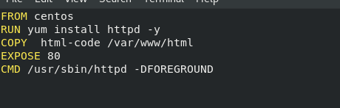

**Step 2:** Build a docker image using the ‘docker build’ command.

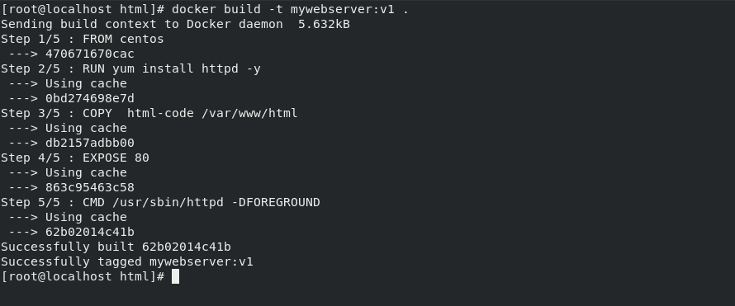

**Step 3:** Changing the name of the file so that it can be uploaded on dockerhub, for this ‘docker tag’ command has been used. Then uploading the image on dockerhub using the ‘docker push’ command.

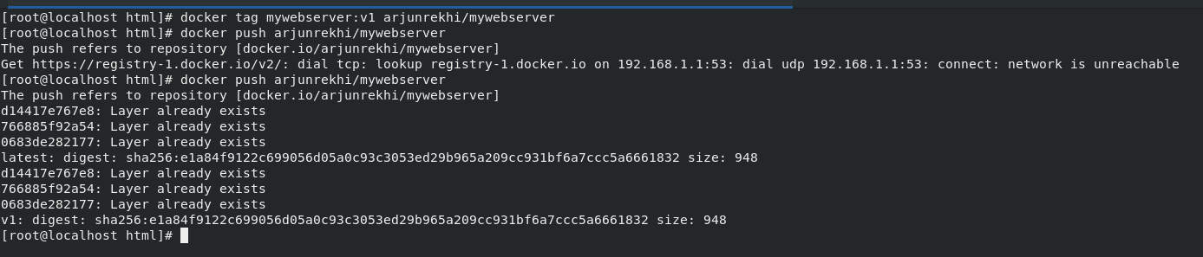

Image has been uploaded on dockerhub and it can be seen on dockerhub

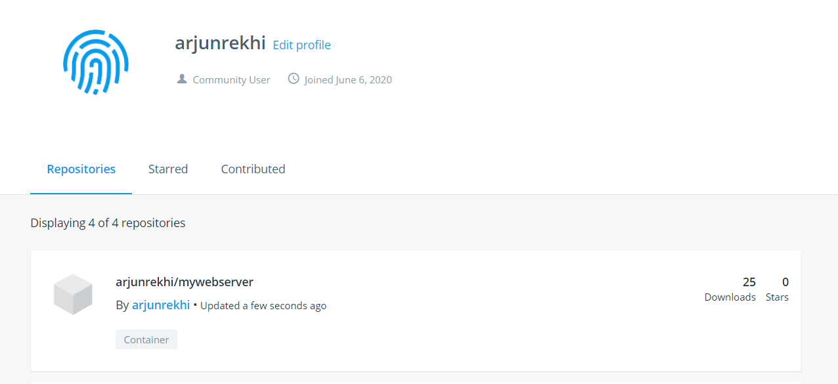

**Step 4:** Now that the image has been posted on dockerhub anyone van download it and create a container. Pulling the image using ‘docker pull’ command.

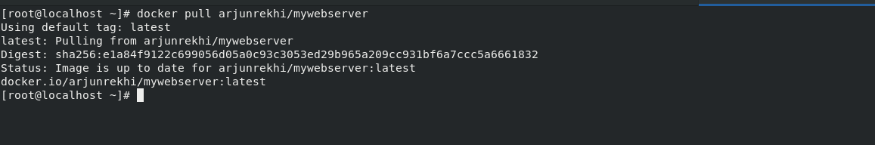

**Step 5:** Creating a container using this image. Command used: ‘docker run –d –p 8089:80 arjunrekhi/mywebserver.’

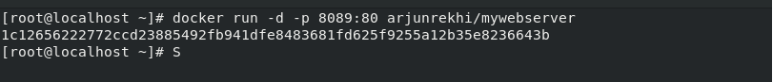

**Step 6:** Viewing the image on the browser:

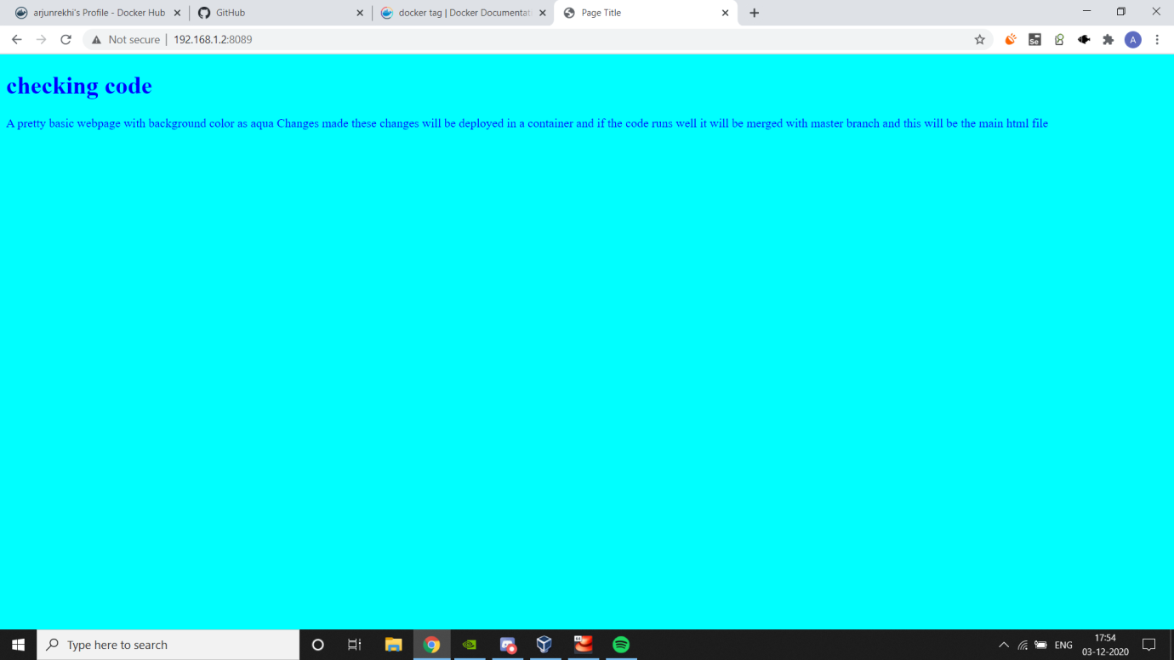

Submitted by:

Arjun Rekhi

500068109

R171218028